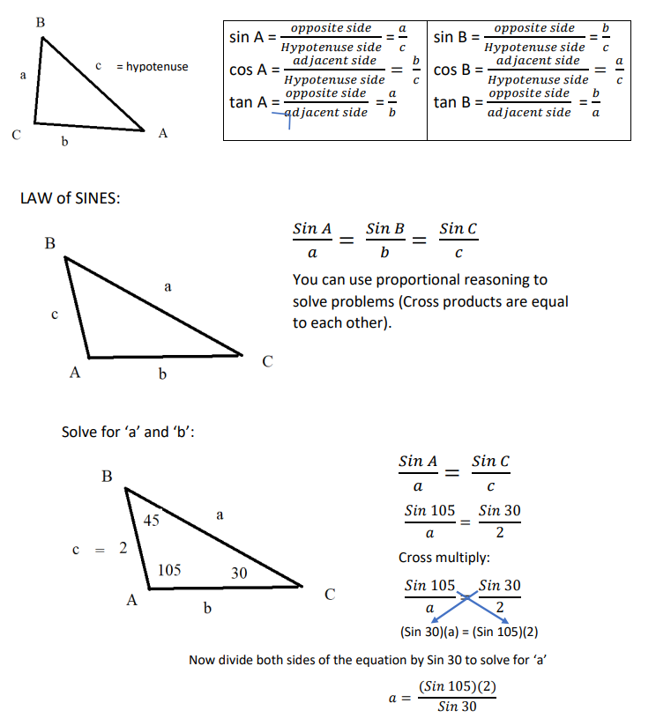

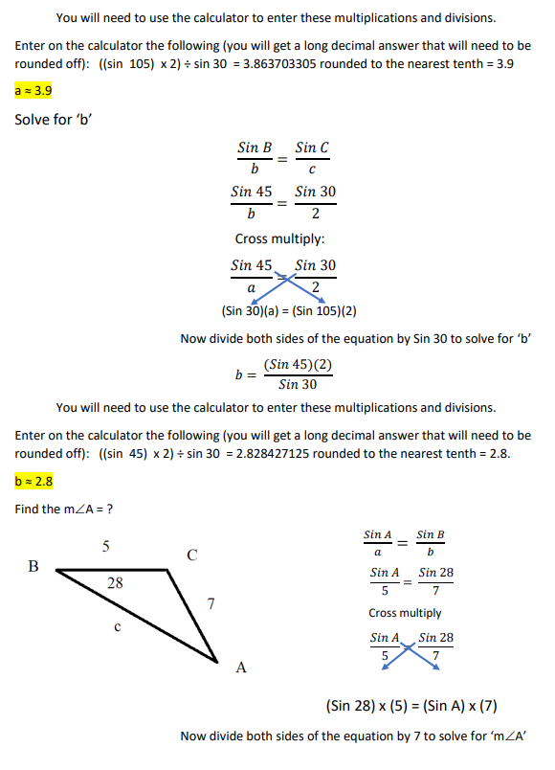

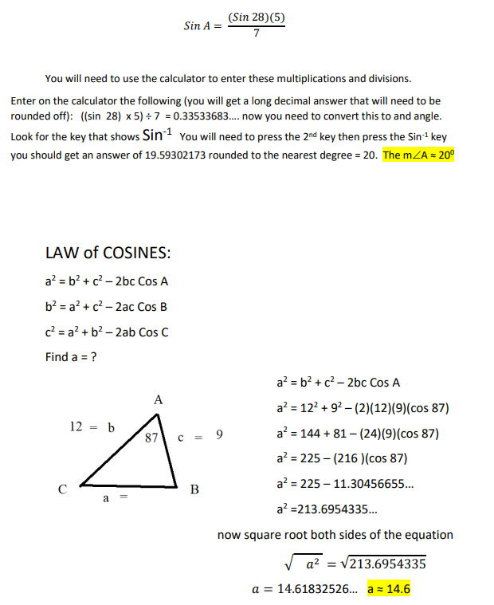

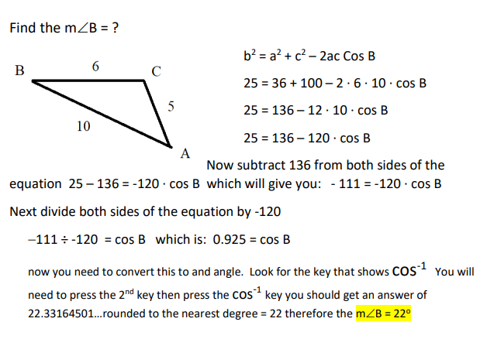

Another way to write the formula for the Law of Cosines that will solve for the angle measure is:

cos(C) = a2 + b2 − c2

**2ab**

cos(A) = b2 + c2 − a2

**2bc**

cos(B) = c2 + a2 − b2

**2ca**

**The previous problem would fit into that formula as follows:**

**Cos-1 B = c2 + a2 – b2**

2ca

Our number substitution gives us **Cos-1 B = 102 + 62 – 52**

2•10•6

**Cos-1 B = 100 + 36 – 25**

120

**Cos-1 B = 111**

120

Angle B = 22.33 or 22.3°